EXP NO 3:
CREATE A SIMPLE CLOUD SOFTWARE APPLICATION FOR PROPERTY BUYING & RENTAL PROCESS (IN CHENNAI CITY) USING ANY CLOUD SERVICE PROVIDER TO DEMONSTRATE SAAS.

AIM: To Create a simple cloud software application for Property Buying & Rental process (In Chennai city) using any Cloud Service Provider to demonstrate SaaS.

PROCEDURE: step1: Go to zoho.com. step 2: Log into the zoho.com. step 3: Select one application step.
step4: Enter application name as property buying & rental. step 5: Created new application as property buying & rental.
step 6: Select one form step 7: The software has been created.

FORM DESIGN:

1.SELLER DETAILS
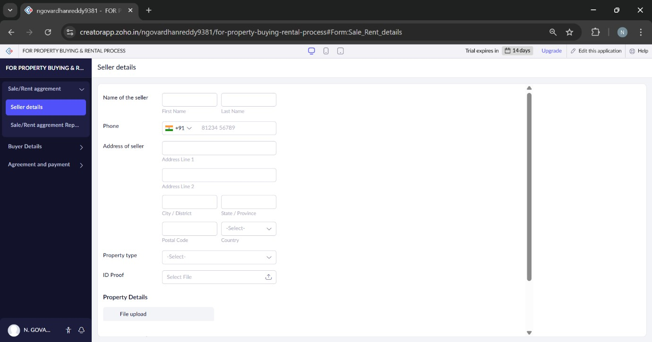
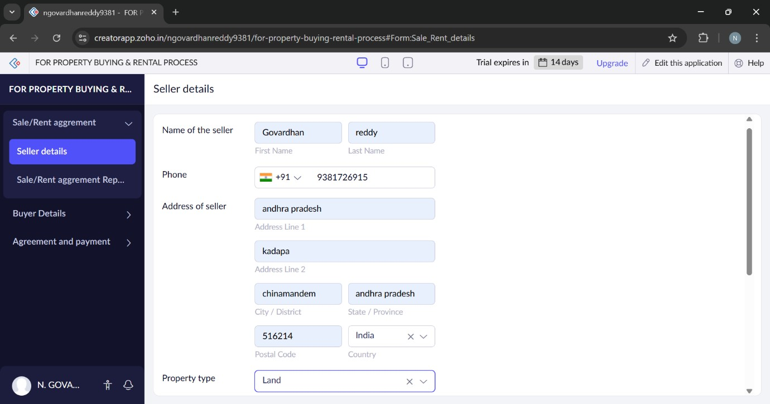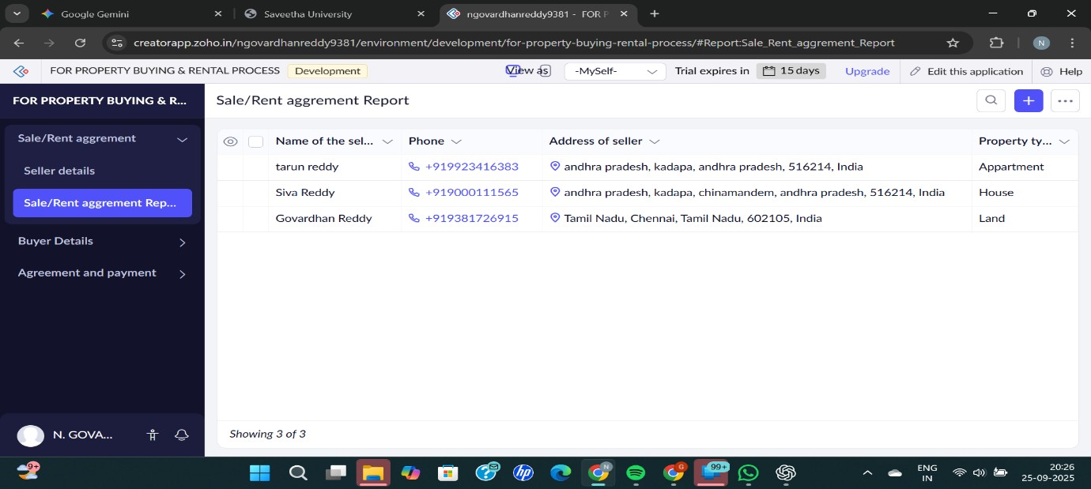

2.BUYER DETAILS
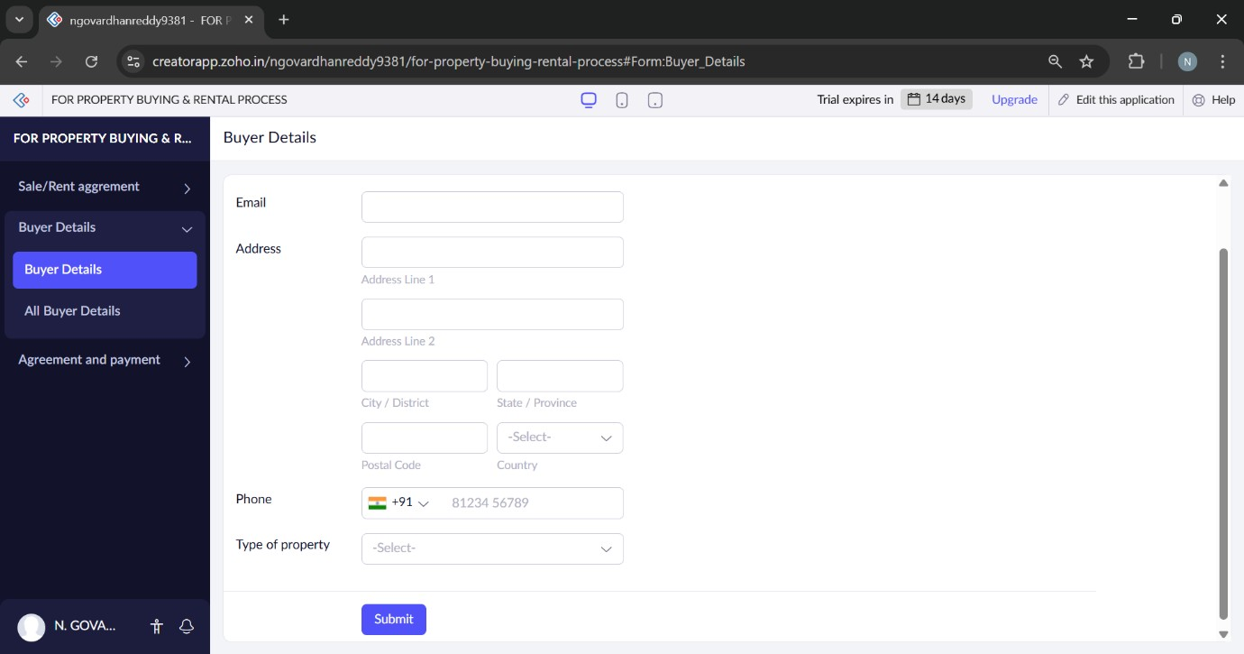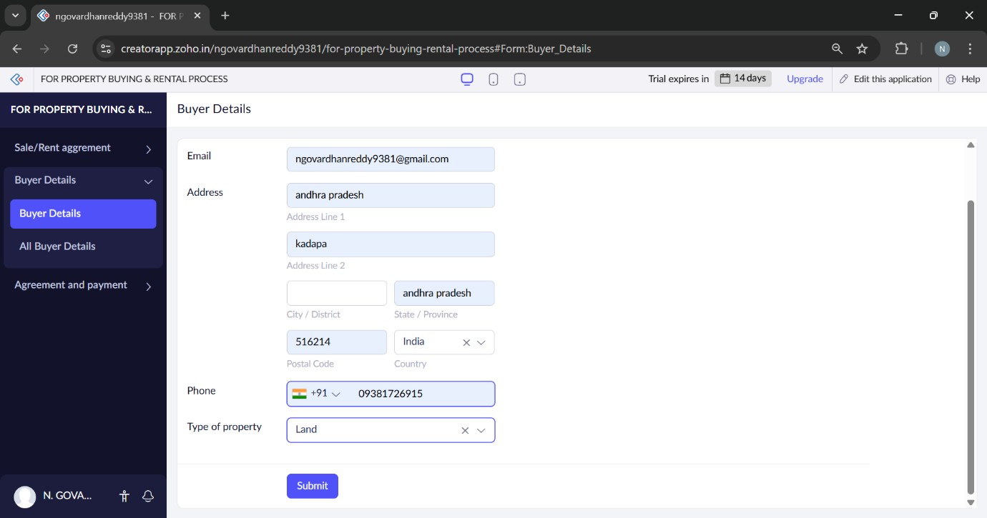
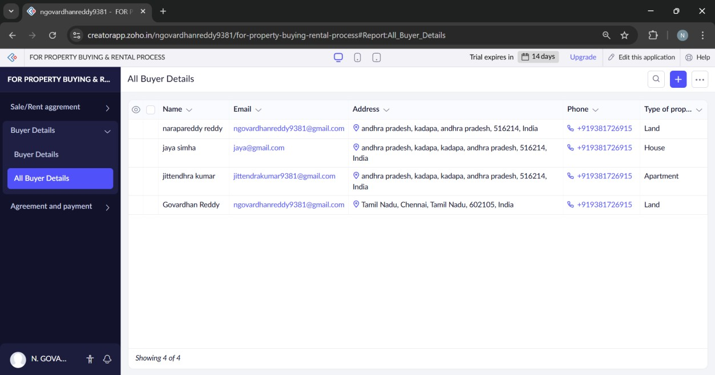

3.AGREEMENT AND PAYMENT
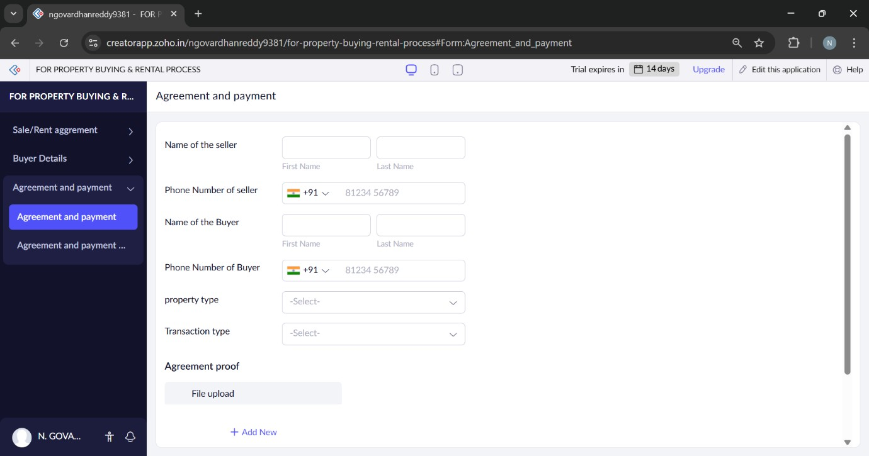
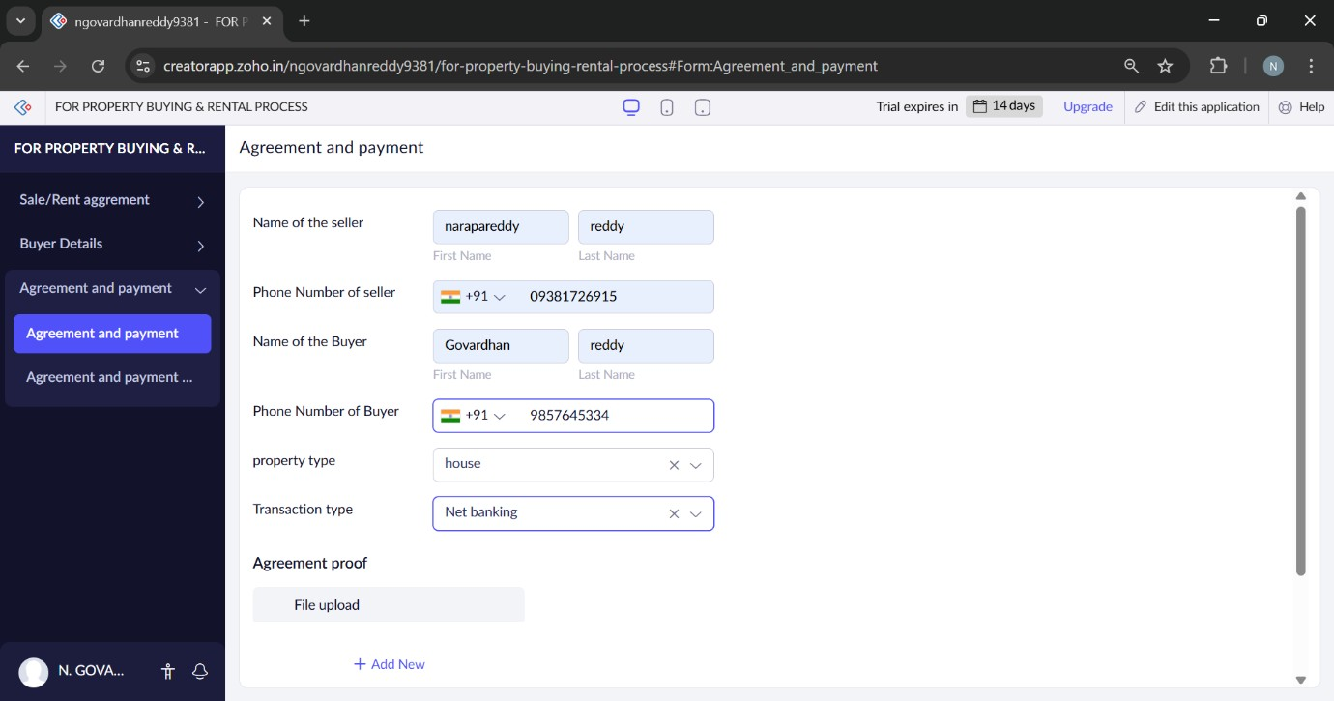
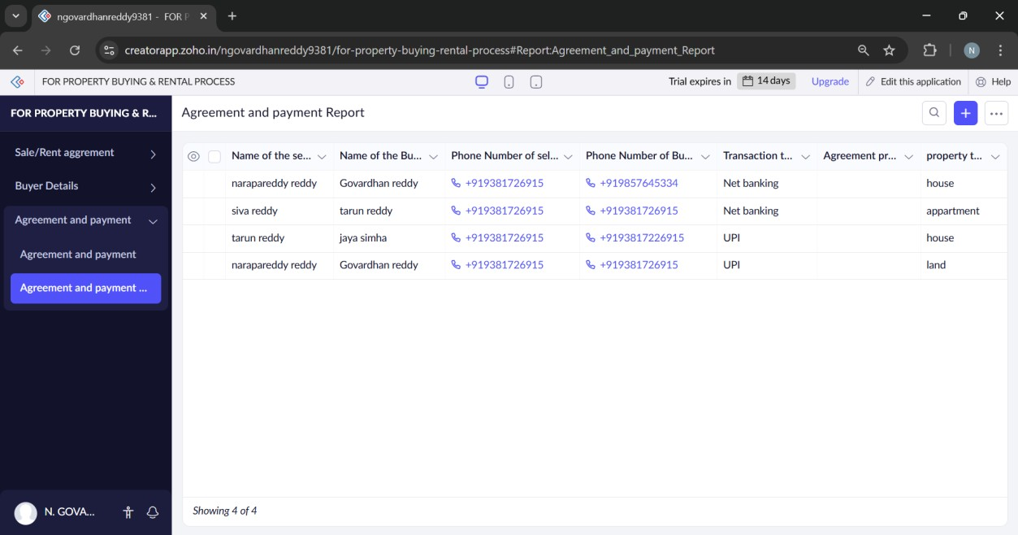
RESULT:
Successfully create a simple cloud software application for property buying & rental process (in Chennai city) using any cloud service provider to demonstrate saas.

